Homework 2 HAN FENG 20407369 [fhanab@connect.ust.hk](mailto:fhanab@connect.ust.hk)

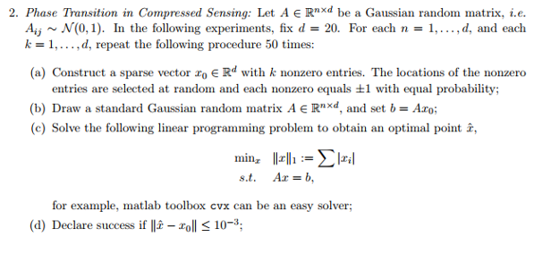

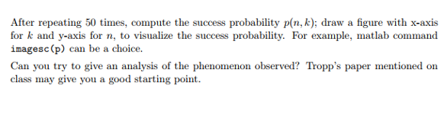

1. Phase transition in CS

library(Rdonlp2)

k = 20

n = 20

norm1 = function(x) { sum(abs(x)) }

pmatrix=matrix(NA,k,n)

for (k in 1:20){

for (n in 1:20){

pro = 0

for (t in 1:50)

{

x0=rep(0,20)

s = sample(20,k)

x0[s] = sample(c(-1,1),k,r=T)

A = matrix(rnorm(20\*n),nrow=n)

b = A %\*% x0

p = rep(1,20)

xhat=donlp2(p,fn = norm1, A = A, lin.l = b, lin.u = b)$par

if (sum(xhat-x0)^2<=10e-3) pro = pro+1

}

pmatrix[k,n] = pro/50

}

}

contour(x=1:20,y=1:20,pmatrix,xlab='k',ylab='n',main='success prob p(n,k)',col="blue")

